**Calculating the quantity of fish discarded in the Barents Sea shrimp trawl fishery**

There are various interpretations of the quantities of fish discarded by the Barents Sea shrimp trawl fishery. First, ICES (2019; Figure 0.1) presents graphs of the discard quantity (millions of individuals) of cod, haddock, Greenland Halibut and redfish in the international shrimp trawl fishery in the Barents Sea during 1994-2018. These graphs, which originate from Breivik *et al*. (2017), represent analysis of sampling aboard Norwegian vessels, assuming that these were representative of the international shrimp trawl effort, and an exploration of various statistical methods for extrapolating to the international discard quantities.

However ICES (2018; Figure 0.1 and Table 3.26) also show interpretations of the quantities of fish discarded in the shrimp trawl fishery, based on unpublished Working Documents by Ajiad *et al*. (2008). The former shows discards (numbers) of cod, haddock and redfish, while the latter shows numbers ate age of cod. Inexplicably, the estimated total numbers of cod discarded in Figure 0.1 and Table 3.26 are highly inconsistent. However, the data in Table 3.26 are consistent with the data from Breivik *et al*. (2017) in ICES (2019).

We accepted the data from ICES (2019) as the best estimate of numbers discarded by the shrimp fishery (Figure 1, Table 1). In order to convert to weight discarded we required estimates of the mean weight per individual of each species. For cod, we calculated mean weight per individual from the numbers at age discarded (ICES 2018; Table 3.26) and mean weight at age in the wider catch of North East Arctic cod (ICES 2018; Table 3.8 – with some extrapolation to ages 0, 1 and 2). In the absence of any data on with the length or age distribution of discarded haddock or halibut, we were forced to assumed the same mean weight per individual as cod (Table 2).

For redfish discards we first assumed that these were mainly *Sebastes mentella*. Again, in the absence of data on age or length distributions of discarded redfish in the shrimp fishery, we estimated the mean weight at age of *S. mentella* in research vessel trawl hauls during the annual Barents Sea Ecosystem Survey. Numbers at age in the survey of *S. mentella* were obtained from ICES (2018; Table 6.16b). Mean weight at age from a combination of fishery and survey data was obtained from ICES (2018; Table 6.7).

The product of annual number per species discarded and mean weight be individual provices an estimate of total weight discarded (Table 3). The results indicate that averaged over 2011-2018 trhe fishery discarded **3867.89 tonnes** of the planktivorous fish guild, and **1822.57 tonnes** of the demersal fish guild. Clearly these are minimum estimates of guild discards since it is likely that other undocumented bycatch species are also discarded.

**References**

Ajiad, A. M. , Aglen, A., Nedreaas, K., and Kvamme, C. 2008. Estimating by-catch at age of Northeast arctic cod from the Norwegian shrimp fishery in the Barents Sea 1984-2006. WD2, ICES. 2008, Report of the Arctic Fisheries Working Group (AFWG),

Breivik, O.N., Storvik, G., & Nedreaas, K. (2017). Latent Gaussian models to predict historical bycatch in commercial fishery. Fisheries Research 185, 62-72.

ICES. 2018. Report of the Arctic Fisheries Working Group (AFWG), 18–24 April 2018, Ispra, Italy. ICES CM 2018/ACOM:06. 859 pp.

ICES. 2019. Arctic Fisheries Working Group (AFWG). ICES Scientific Reports. 1:30. 934 pp. <http://doi.org/10.17895/ices.pub.5292>

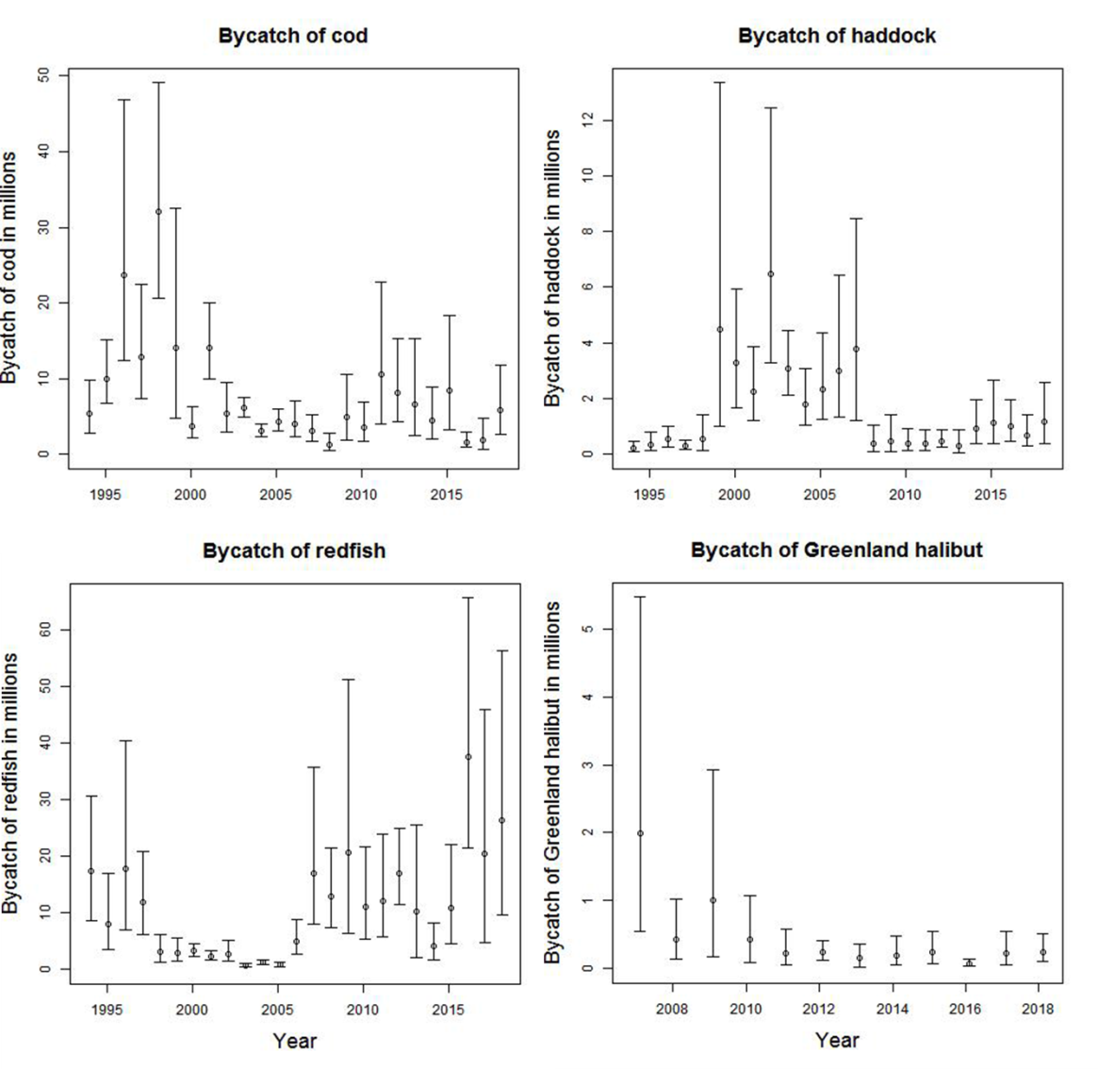

**Figure 1**. Annual bycatch (discards; millions) from the Barents Sea shrimp trawl fishery. Images from ICES 2019; Figure 0.1 – “Estimated bycatch of cod, redfish, haddock, and Greenland Halibut in the Barents Sea shrimp fishery. Intervals are 90% confidence intervals”. Original data from Breivik et al. 2017.

**Table 1**. Annual mean numbers of cod, haddock, halibut and redfish discarded by the Barents Sea shrimp trawl fishery, digitised from Figure 1. “nd” indicates no data.

|  |  |  |  |  |
| --- | --- | --- | --- | --- |
|  | Numbers discarded (millions) | | | |
| Year | Cod | Haddock | Redfish | Halibut |
| 1994 | 5.4487 | 0.3057 | 17.5439 | nd |
| 1995 | 9.6154 | 0.4586 | 8.0702 | nd |
| 1996 | 23.3974 | 0.6115 | 17.8947 | nd |
| 1997 | 12.5000 | 0.3822 | 11.5789 | nd |
| 1998 | 31.7308 | 0.6115 | 3.1579 | nd |
| 1999 | 13.7821 | 5.1975 | 3.1579 | nd |
| 2000 | 3.5256 | 3.7452 | 3.5088 | nd |
| 2001 | 13.7821 | 2.5223 | 2.4561 | nd |
| 2002 | 5.1282 | 7.3376 | 2.8070 | nd |
| 2003 | 5.7692 | 3.5159 | 1.0526 | nd |
| 2004 | 2.8846 | 2.0637 | 1.4035 | nd |
| 2005 | 4.1667 | 2.5987 | 1.0526 | nd |
| 2006 | 3.8462 | 3.3631 | 5.2632 | nd |
| 2007 | 2.8846 | 4.2803 | 17.1930 | 2.0055 |
| 2008 | 1.6026 | 0.4586 | 12.9825 | 0.4670 |
| 2009 | 4.8077 | 0.5350 | 20.7018 | 1.0714 |
| 2010 | 3.5256 | 0.4586 | 11.2281 | 0.4670 |
| 2011 | 10.2564 | 0.4586 | 12.2807 | 0.2198 |
| 2012 | 8.0128 | 0.5350 | 17.1930 | 0.2747 |
| 2013 | 6.4103 | 0.4586 | 10.5263 | 0.1923 |
| 2014 | 4.1667 | 1.1465 | 4.2105 | 0.2198 |
| 2015 | 8.3333 | 1.3758 | 10.8772 | 0.2473 |
| 2016 | 1.2821 | 1.2229 | 37.5439 | 0.0824 |
| 2017 | 1.6026 | 0.8408 | 20.7018 | 0.2473 |
| 2018 | 5.4487 | 1.4522 | 26.6667 | 0.2747 |
|  |  |  |  |  |
| Mean 2011-2018 | 5.6891 | 0.9363 | 17.5000 | 0.2198 |

**Table 2**. Estimates of annual mean weight per individual for species discarded by the Barents Sea shrimp trawl fishery. Data for cod derived from numbers at age discarded (ICES 2018; Table 3.26) and mean weight at age in the wider catch of North East Arctic cod (ICES 2018; Table 3). Redfish discards assumed to be *Sebastes mentella,* with mean weight derived fromnumbers at age in the annual Barents Sea Ecosystem Survey trawl catches (2018; Table 6.16b) and mean weight at age from ICES (2018; Table 6.7). Mean weigh per individual in discards for haddock and halibut assumed equal to cod.

|  |  |  |  |  |
| --- | --- | --- | --- | --- |
|  | Mean weight per individual (kg) in discards | | | |
| Year | Cod | Haddock | Redfish | Halibut |
| 1994 | 0.284 | 0.284 | 0.175 | 0.284 |
| 1995 | 0.245 | 0.245 | 0.148 | 0.245 |
| 1996 | 0.287 | 0.287 | 0.165 | 0.287 |
| 1997 | 0.253 | 0.253 | 0.239 | 0.253 |
| 1998 | 0.264 | 0.264 | 0.191 | 0.264 |
| 1999 | 0.226 | 0.226 | 0.246 | 0.226 |
| 2000 | 0.307 | 0.307 | 0.252 | 0.307 |
| 2001 | 0.250 | 0.250 | 0.265 | 0.250 |
| 2002 | 0.364 | 0.364 | 0.283 | 0.364 |
| 2003 | 0.213 | 0.213 | 0.370 | 0.213 |
| 2004 | 0.252 | 0.252 | 0.322 | 0.252 |
| 2005 | 0.280 | 0.280 | 0.390 | 0.280 |
| 2006 | 0.236 | 0.236 | 0.372 | 0.236 |
| 2007 | 0.266 | 0.266 | 0.128 | 0.266 |
| 2008 | 0.266 | 0.266 | 0.107 | 0.266 |
| 2009 | 0.266 | 0.266 | 0.142 | 0.266 |
| 2010 | 0.266 | 0.266 | 0.131 | 0.266 |
| 2011 | 0.266 | 0.266 | 0.100 | 0.266 |
| 2012 | 0.266 | 0.266 | 0.224 | 0.266 |
| 2013 | 0.266 | 0.266 | 0.226 | 0.266 |
| 2014 | 0.266 | 0.266 | 0.231 | 0.266 |
| 2015 | 0.266 | 0.266 | 0.234 | 0.266 |
| 2016 | 0.266 | 0.266 | 0.234 | 0.266 |
| 2017 | 0.266 | 0.266 | 0.236 | 0.266 |
| 2018 | 0.266 | 0.266 | 0.236 | 0.266 |
|  |  |  |  |  |
| Mean 2011-2018 | 0.266 | 0.266 | 0.215 | 0.266 |

**Table 3**. Total annual weight (tonnes) of species and guilds discarded by the Barents Sea shrimp trawl fishery. Species weights derived by the product of Tables 1 and 2. “nd” indicates no data. Guoild discarded weights: planktivorous fish = redfish; demersal fish = cod + haddock + halibut. Demersal fish weights in brackets – partial estimates lacking data on halibut.

|  |  |  |  |  |  |  |
| --- | --- | --- | --- | --- | --- | --- |
|  | Species total weight discarded (tonnes) | | | | Guild total weight discarded (tonnes) | |
| Year | Cod | Haddock | Redfish | Halibut | Planktivorous fish | Demersal fish |
| 1994 | 1544.90 | 86.69 | 3068.61 | nd | 3068.61 | (1631.59) |
| 1995 | 2353.39 | 112.24 | 1192.03 | nd | 1192.03 | (2465.64) |
| 1996 | 6724.64 | 175.74 | 2952.90 | nd | 2952.90 | (6900.38) |
| 1997 | 3165.39 | 96.78 | 2770.10 | nd | 2770.10 | (3262.17) |
| 1998 | 8380.41 | 161.49 | 604.71 | nd | 604.71 | (8541.90) |
| 1999 | 3111.16 | 1173.27 | 775.94 | nd | 775.94 | (4284.43) |
| 2000 | 1083.79 | 1151.29 | 884.43 | nd | 884.43 | (2235.08) |
| 2001 | 3440.86 | 629.72 | 650.05 | nd | 650.05 | (4070.58) |
| 2002 | 1869.01 | 2674.23 | 793.92 | nd | 793.92 | (4543.25) |
| 2003 | 1228.41 | 748.62 | 389.32 | nd | 389.32 | (1977.03) |
| 2004 | 727.46 | 520.44 | 452.07 | nd | 452.07 | (1247.90) |
| 2005 | 1164.61 | 726.36 | 410.76 | nd | 410.76 | (1890.97) |
| 2006 | 909.24 | 795.04 | 1955.84 | nd | 1955.84 | (1704.28) |
| 2007 | 768.04 | 1139.64 | 2199.80 | 533.97 | 2199.80 | 2441.66 |
| 2008 | 426.69 | 122.10 | 1384.59 | 124.35 | 1384.59 | 673.15 |
| 2009 | 1280.07 | 142.46 | 2931.86 | 285.27 | 2931.86 | 1707.80 |
| 2010 | 938.72 | 122.10 | 1470.98 | 124.35 | 1470.98 | 1185.18 |
| 2011 | 2730.82 | 122.10 | 1227.08 | 58.52 | 1227.08 | 2911.45 |
| 2012 | 2133.46 | 142.46 | 3844.13 | 73.15 | 3844.13 | 2349.06 |
| 2013 | 1706.77 | 122.10 | 2382.02 | 51.20 | 2382.02 | 1880.07 |
| 2014 | 1109.40 | 305.26 | 971.19 | 58.52 | 971.19 | 1473.18 |
| 2015 | 2218.80 | 366.31 | 2548.57 | 65.83 | 2548.57 | 2650.94 |
| 2016 | 341.35 | 325.61 | 8786.39 | 21.94 | 8786.39 | 688.91 |
| 2017 | 426.69 | 223.86 | 4893.76 | 65.83 | 4893.76 | 716.38 |
| 2018 | 1450.75 | 386.66 | 6290.01 | 73.15 | 6290.01 | 1910.56 |
|  |  |  |  |  |  |  |
| Mean 2011-2018 | 1514.75 | 249.30 | 3867.89 | 58.52 | **3867.89** | **1822.57** |